Terraform Task-2

Task Description:

Create 2 EC2 instances on 2 different regions and install nginx using terraform script.

Techstacks needs to be used :

- AWS EC2
- Terraform
- AWS CLI
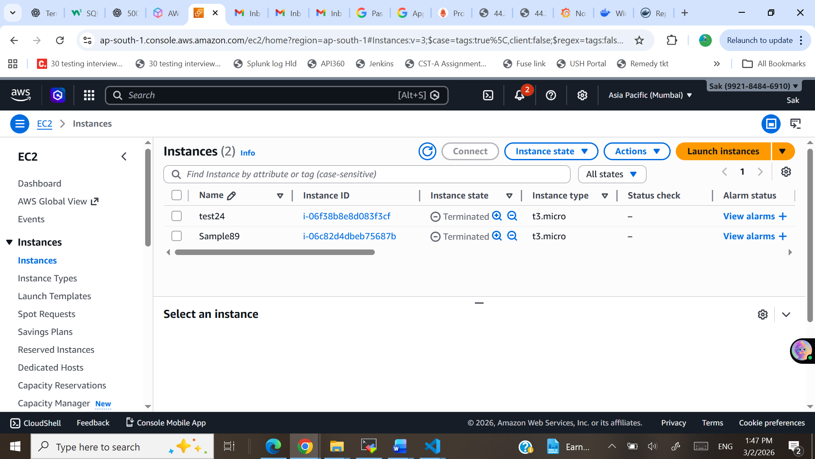
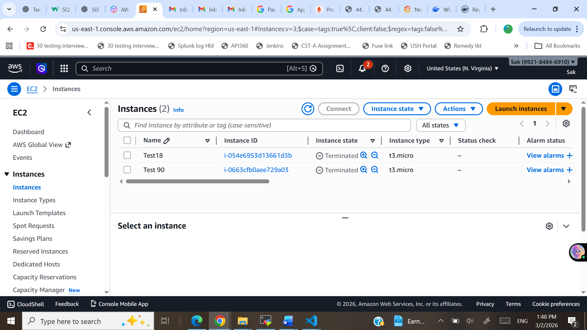
provider "aws" {
alias = "useast"
region = "us-east-1"
}
provider "aws" {
alias = "mumbai"
region = "ap-south-1"
}
resource "aws_vpc" "vpc_useast" {
provider = aws.useast
cidr_block = "10.0.0.0/16"

tags = { Name = "USEast-VPC" }
}

resource "aws_subnet" "subnet_useast" {
provider = aws.useast
vpc_id = aws_vpc.vpc_useast.id
cidr_block = "10.0.1.0/24"
availability_zone = "us-east-1a"

tags = { Name = "USEast-Subnet" }
}

resource "aws_internet_gateway" "igw_useast" {
provider = aws.useast
vpc_id = aws_vpc.vpc_useast.id

tags = { Name = "USEast-IGW" }
}

resource "aws_route_table" "rt_useast" {
provider = aws.useast
vpc_id = aws_vpc.vpc_useast.id

route {
cidr_block = "0.0.0.0/0"
gateway_id = aws_internet_gateway.igw_useast.id
}

tags = { Name = "USEast-RT" }
}

resource "aws_route_table_association" "rta_useast" {
provider = aws.useast
subnet_id = aws_subnet.subnet_useast.id
route_table_id = aws_route_table.rt_useast.id
}

resource "aws_security_group" "sg_useast" {
provider = aws.useast
vpc_id = aws_vpc.vpc_useast.id

ingress {
from_port = 22
to_port = 22
protocol = "tcp"
cidr_blocks = ["0.0.0.0/0"]
}

ingress {
from_port = 80
to_port = 80
protocol = "tcp"
cidr_blocks = ["0.0.0.0/0"]
}

egress {
from_port = 0
to_port = 0
protocol = "-1"
cidr_blocks = ["0.0.0.0/0"]
}

tags = { Name = "USEast-SG" }
}

resource "aws_instance" "instance_useast" {
provider = aws.useast
ami = "ami-0f3caa1cf4417e51b"
instance_type = "t3.micro"
subnet_id = aws_subnet.subnet_useast.id
vpc_security_group_ids = [aws_security_group.sg_useast.id]
associate_public_ip_address = true
user_data = <<-EOF
#!/bin/bash
yum update -y
yum install -y nginx
systemctl start nginx
systemctl enable nginx
echo "Hello from US EAST Server" > /usr/share/nginx/html/index.html
EOF
tags = { Name = "USEast-Instance" }
}
resource "aws_vpc" "vpc_mumbai" {
provider = aws.mumbai
cidr_block = "10.1.0.0/16"

tags = {
Name = "Mumbai-VPC"
}
}

resource "aws_subnet" "subnet_mumbai" {
provider = aws.mumbai
vpc_id = aws_vpc.vpc_mumbai.id
cidr_block = "10.1.1.0/24"
availability_zone = "ap-south-1a"

tags = {
Name = "Mumbai-Subnet"
}
}

resource "aws_internet_gateway" "igw_mumbai" {
provider = aws.mumbai
vpc_id = aws_vpc.vpc_mumbai.id

tags = {
Name = "Mumbai-IGW"
}
}

resource "aws_route_table" "rt_mumbai" {
provider = aws.mumbai
vpc_id = aws_vpc.vpc_mumbai.id

route {
cidr_block = "0.0.0.0/0"
gateway_id = aws_internet_gateway.igw_mumbai.id
}

tags = {
Name = "Mumbai-RT"
}
}

resource "aws_route_table_association" "rta_mumbai" {
provider = aws.mumbai
subnet_id = aws_subnet.subnet_mumbai.id
route_table_id = aws_route_table.rt_mumbai.id
}

resource "aws_security_group" "sg_mumbai" {
provider = aws.mumbai
vpc_id = aws_vpc.vpc_mumbai.id

ingress {
from_port = 22
to_port = 22
protocol = "tcp"
cidr_blocks = ["0.0.0.0/0"]
}

ingress {
from_port = 80
to_port = 80
protocol = "tcp"
cidr_blocks = ["0.0.0.0/0"]
}

egress {
from_port = 0
to_port = 0
protocol = "-1"
cidr_blocks = ["0.0.0.0/0"]
}

tags = {
Name = "Mumbai-SG"
}
}

resource "aws_instance" "instance_mumbai" {
provider = aws.mumbai
ami = "ami-0f5ee92e2d63afc18"
instance_type = "t3.micro"
subnet_id = aws_subnet.subnet_mumbai.id
vpc_security_group_ids = [aws_security_group.sg_mumbai.id]
associate_public_ip_address = true
user_data = <<-EOF
#!/bin/bash
yum update -y
yum install -y nginx
systemctl start nginx
systemctl enable nginx
echo "Hello from US Mumbai Server" > /usr/share/nginx/html/index.html
EOF
tags = {
Name = "Mumbai-Instance"
}
}
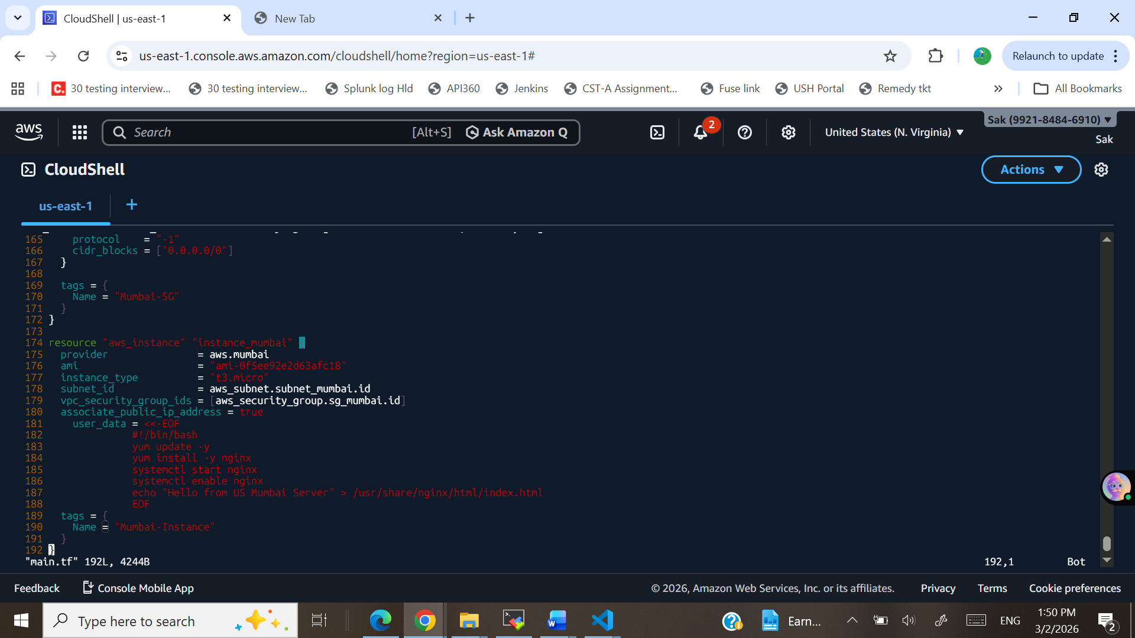
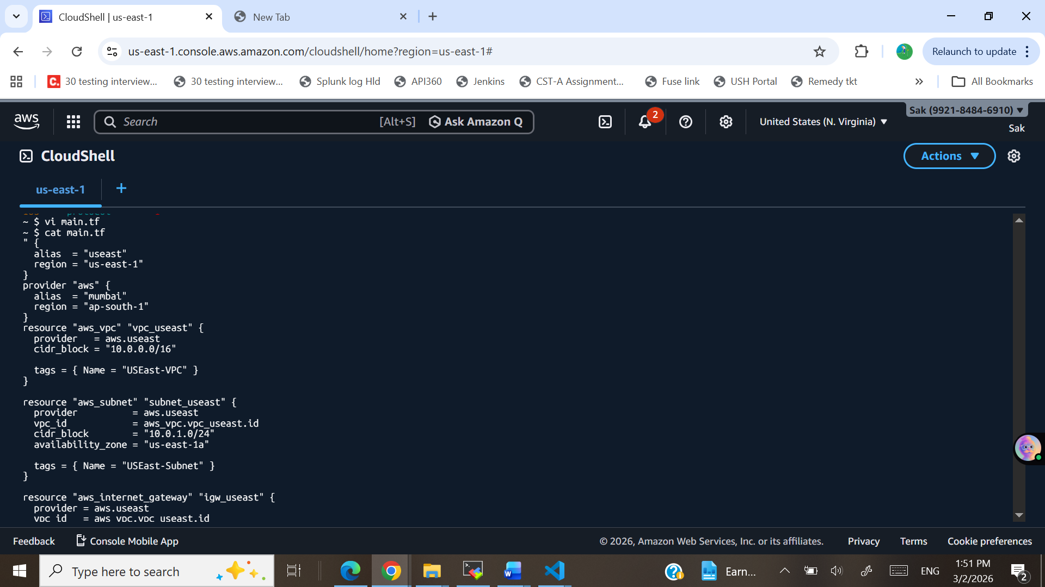
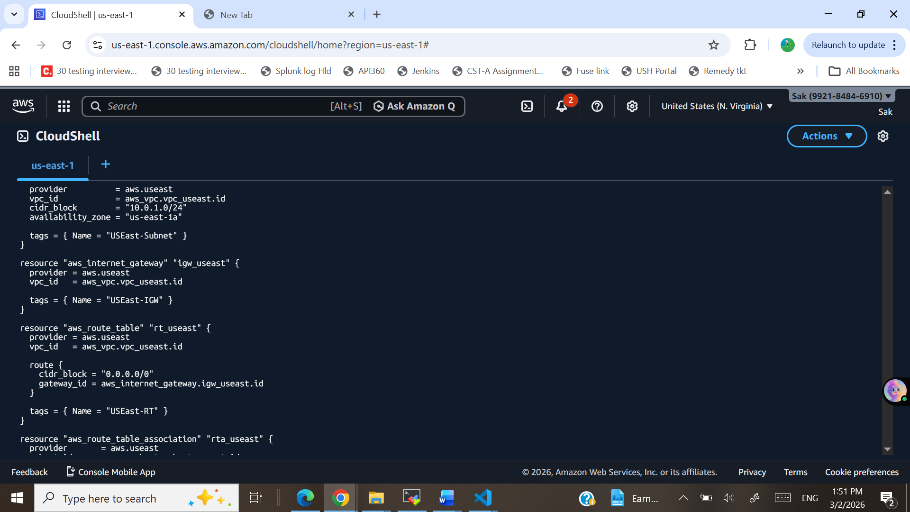
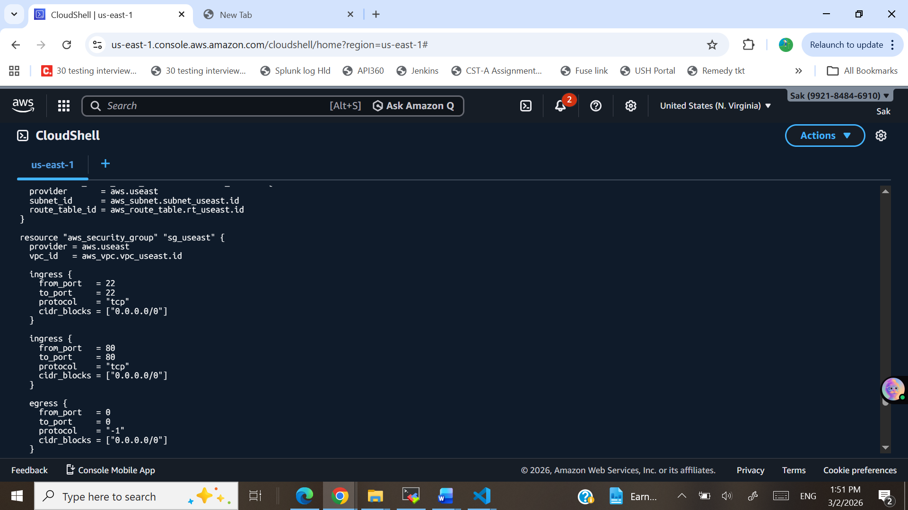
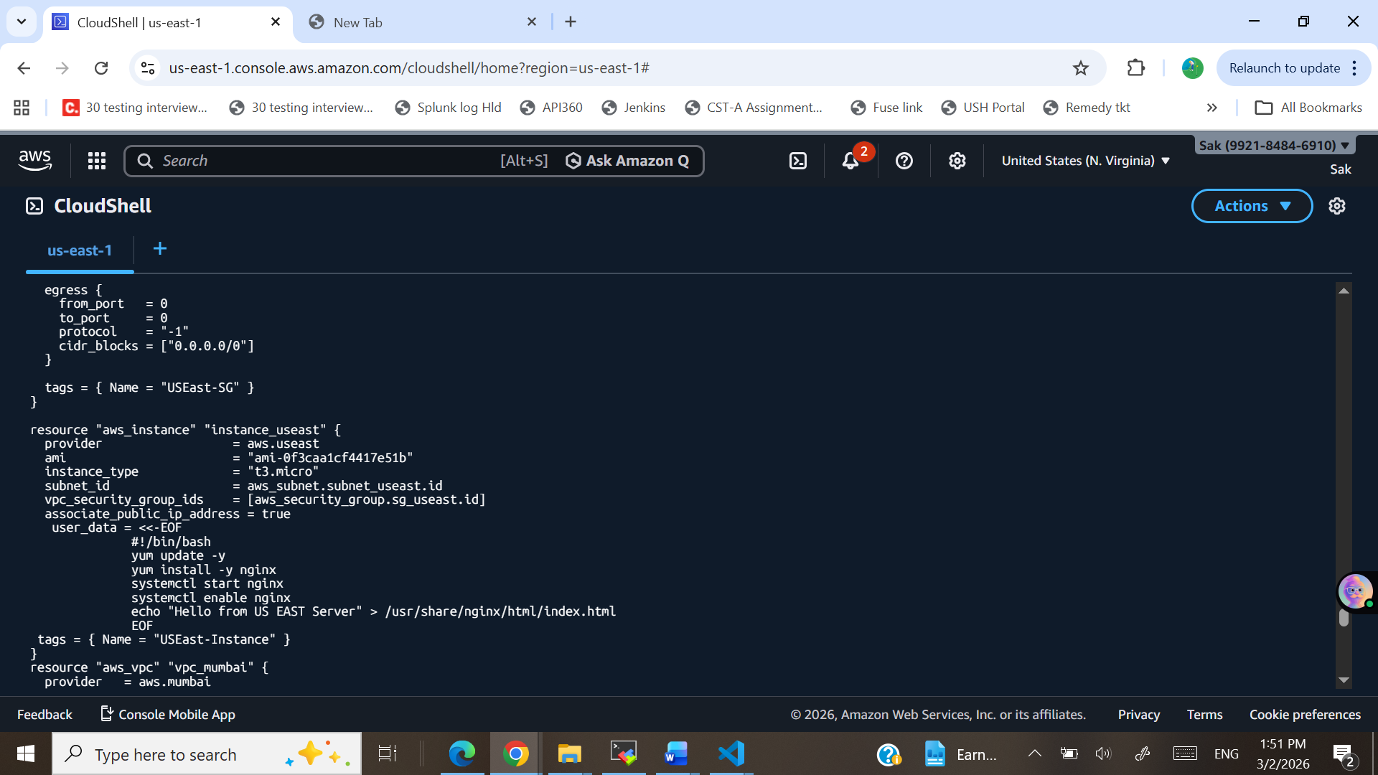
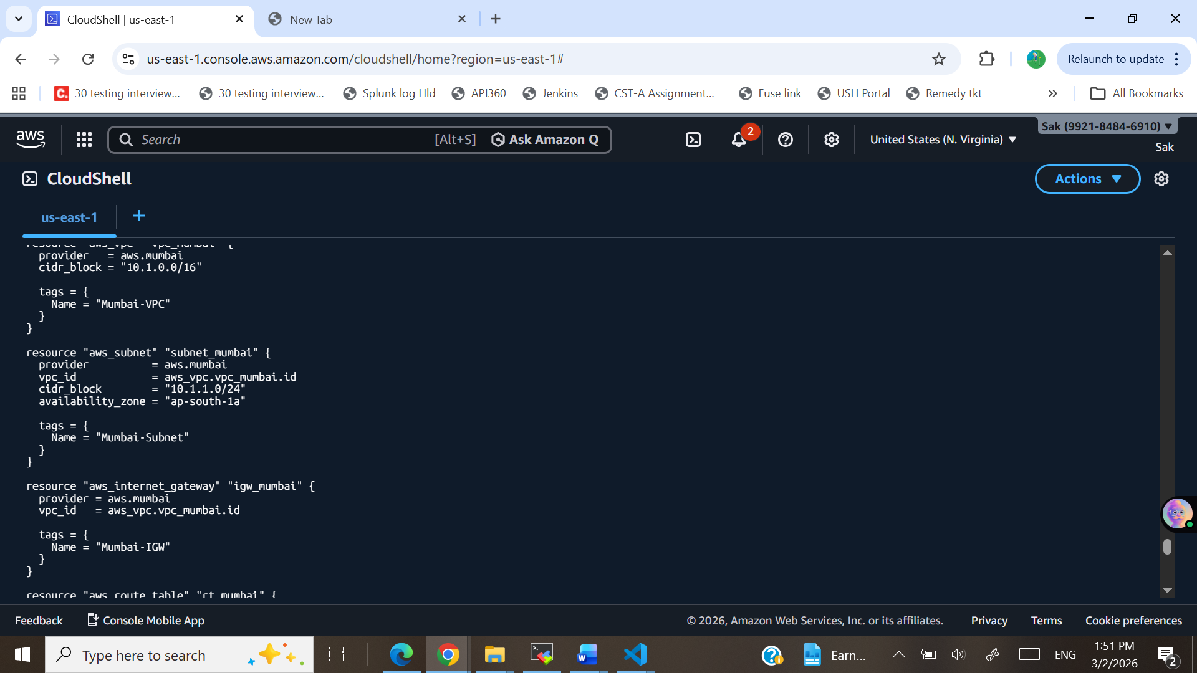
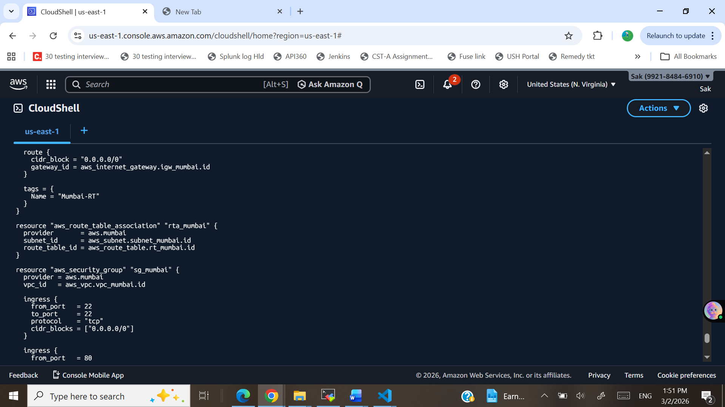
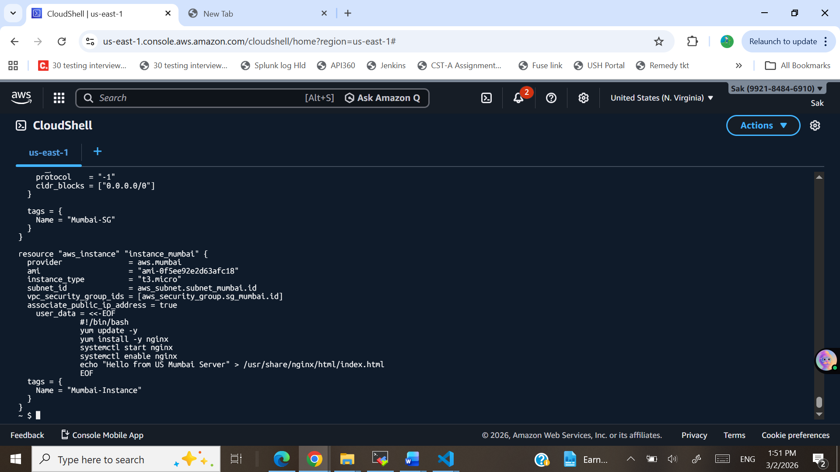
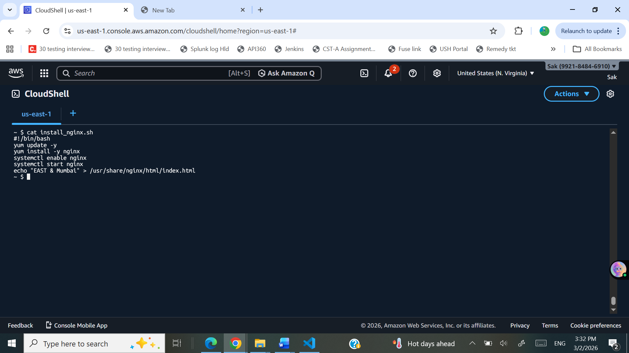
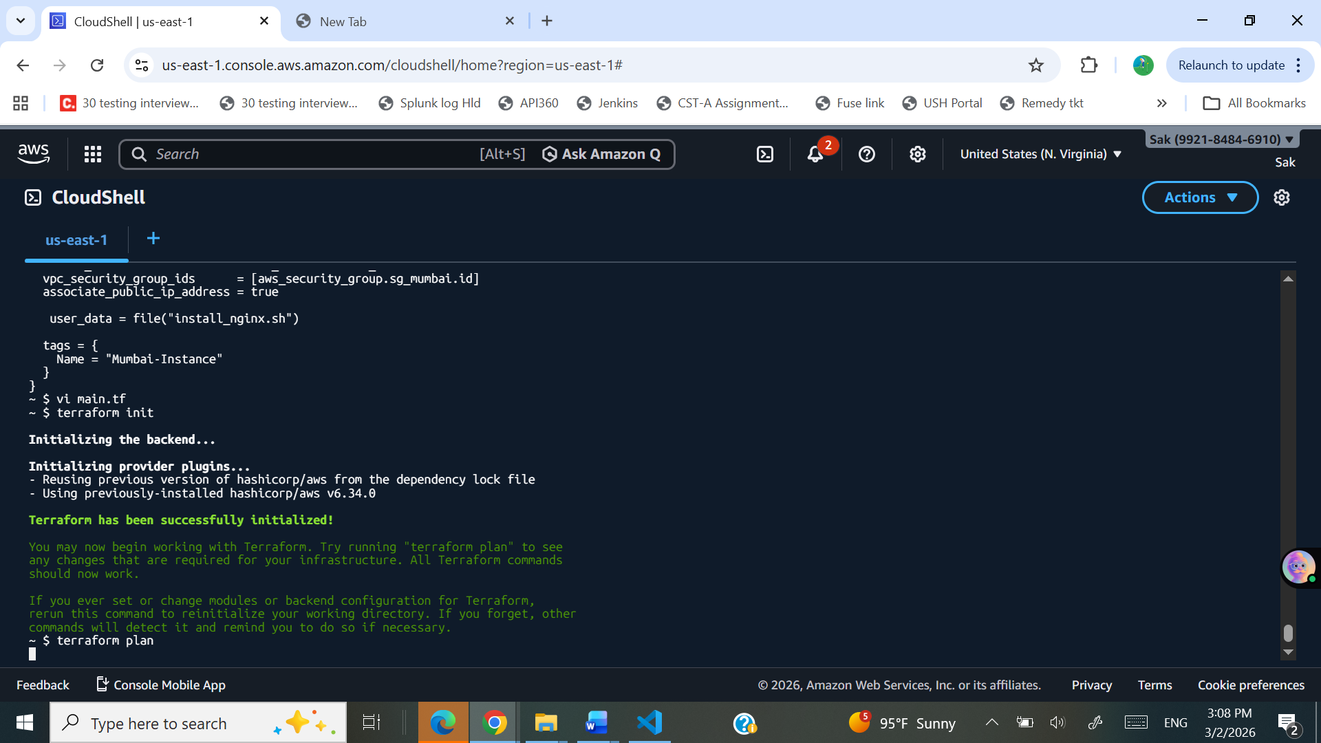
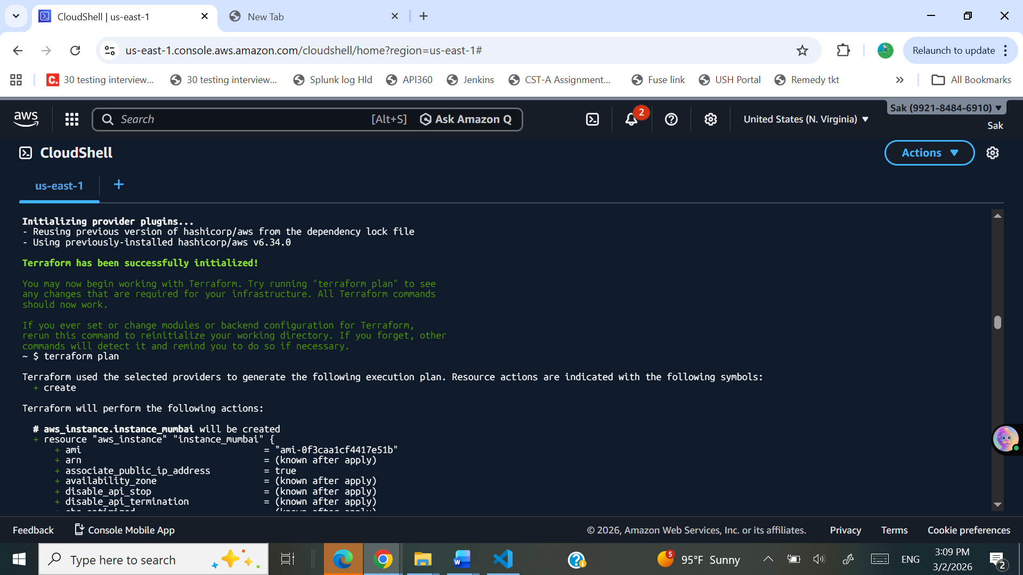
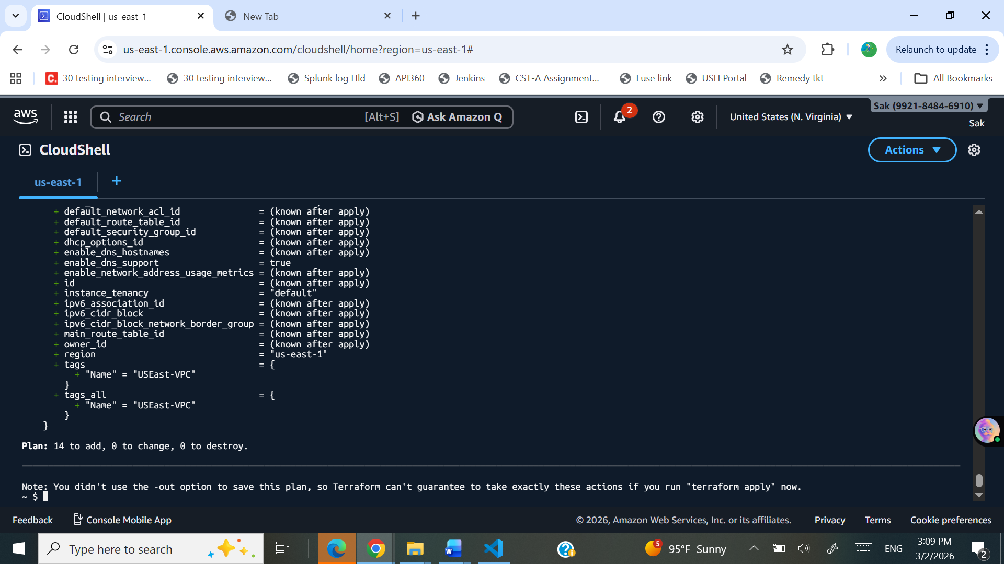
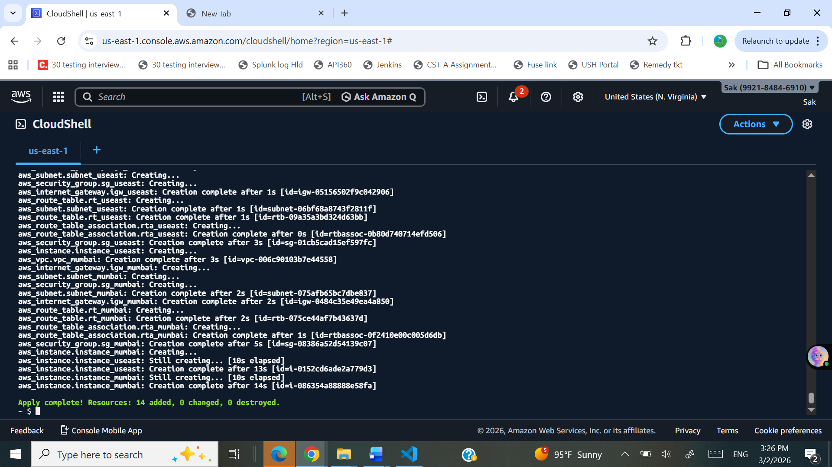

East Region: IP Address: 44.213.118.219
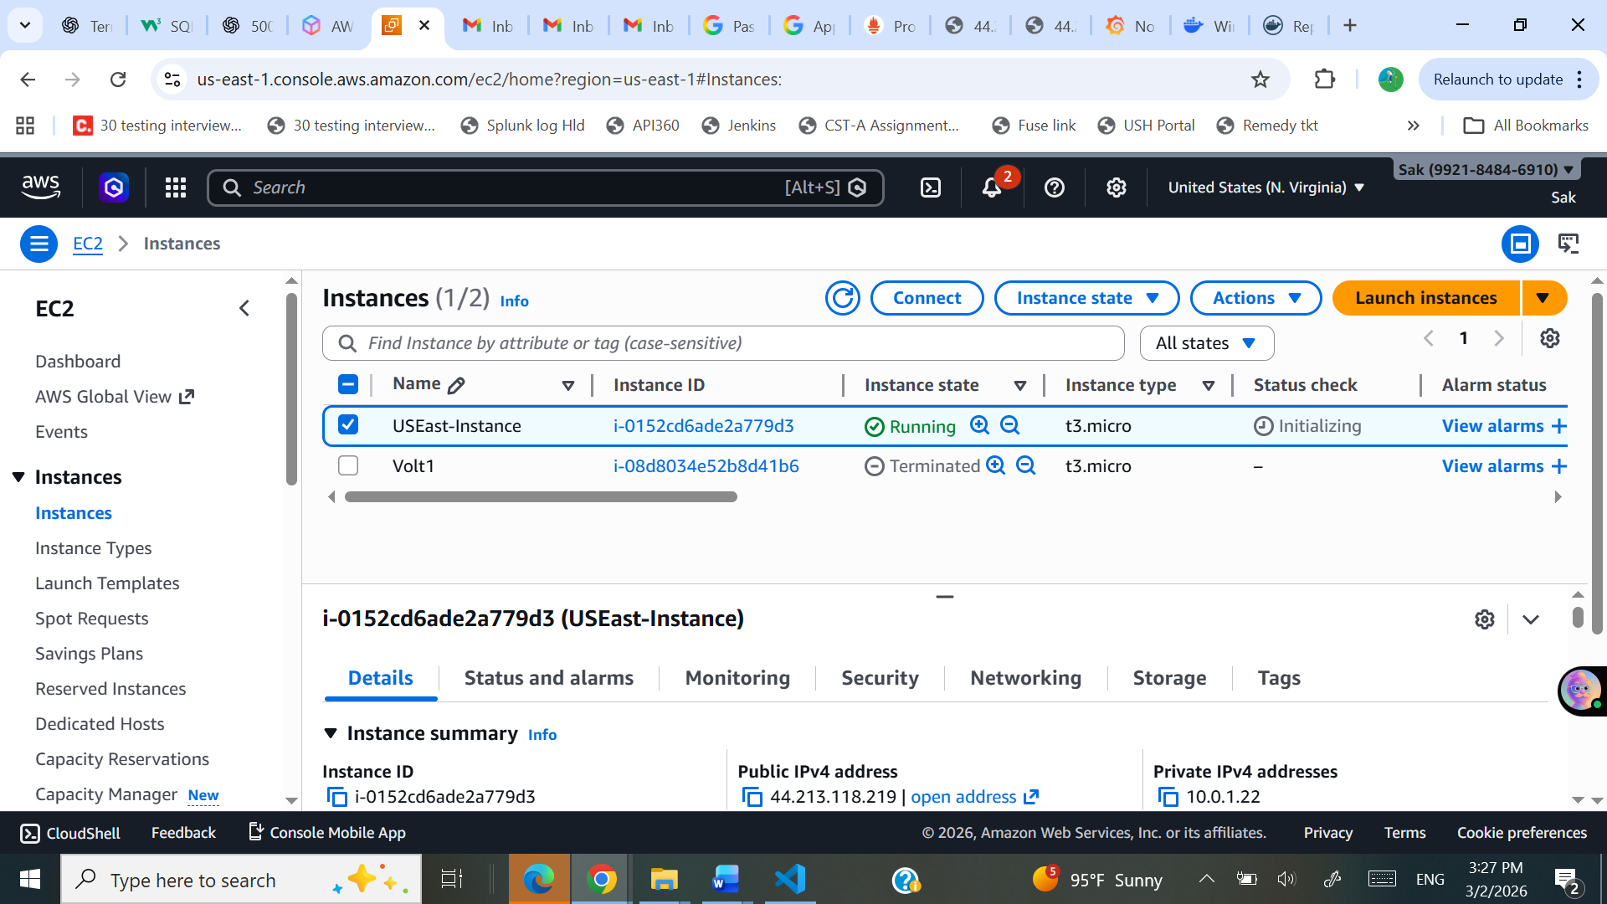
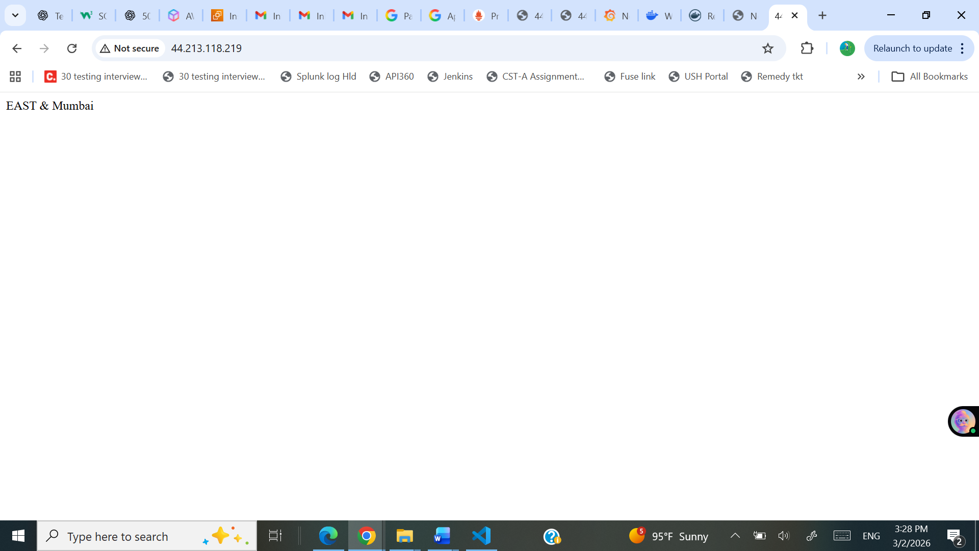

Mumbai Region: IP Address: 43.205.228.190
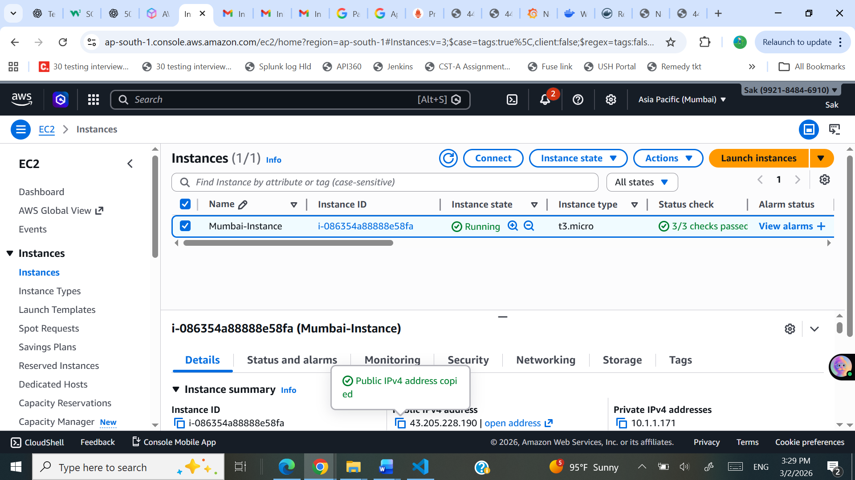

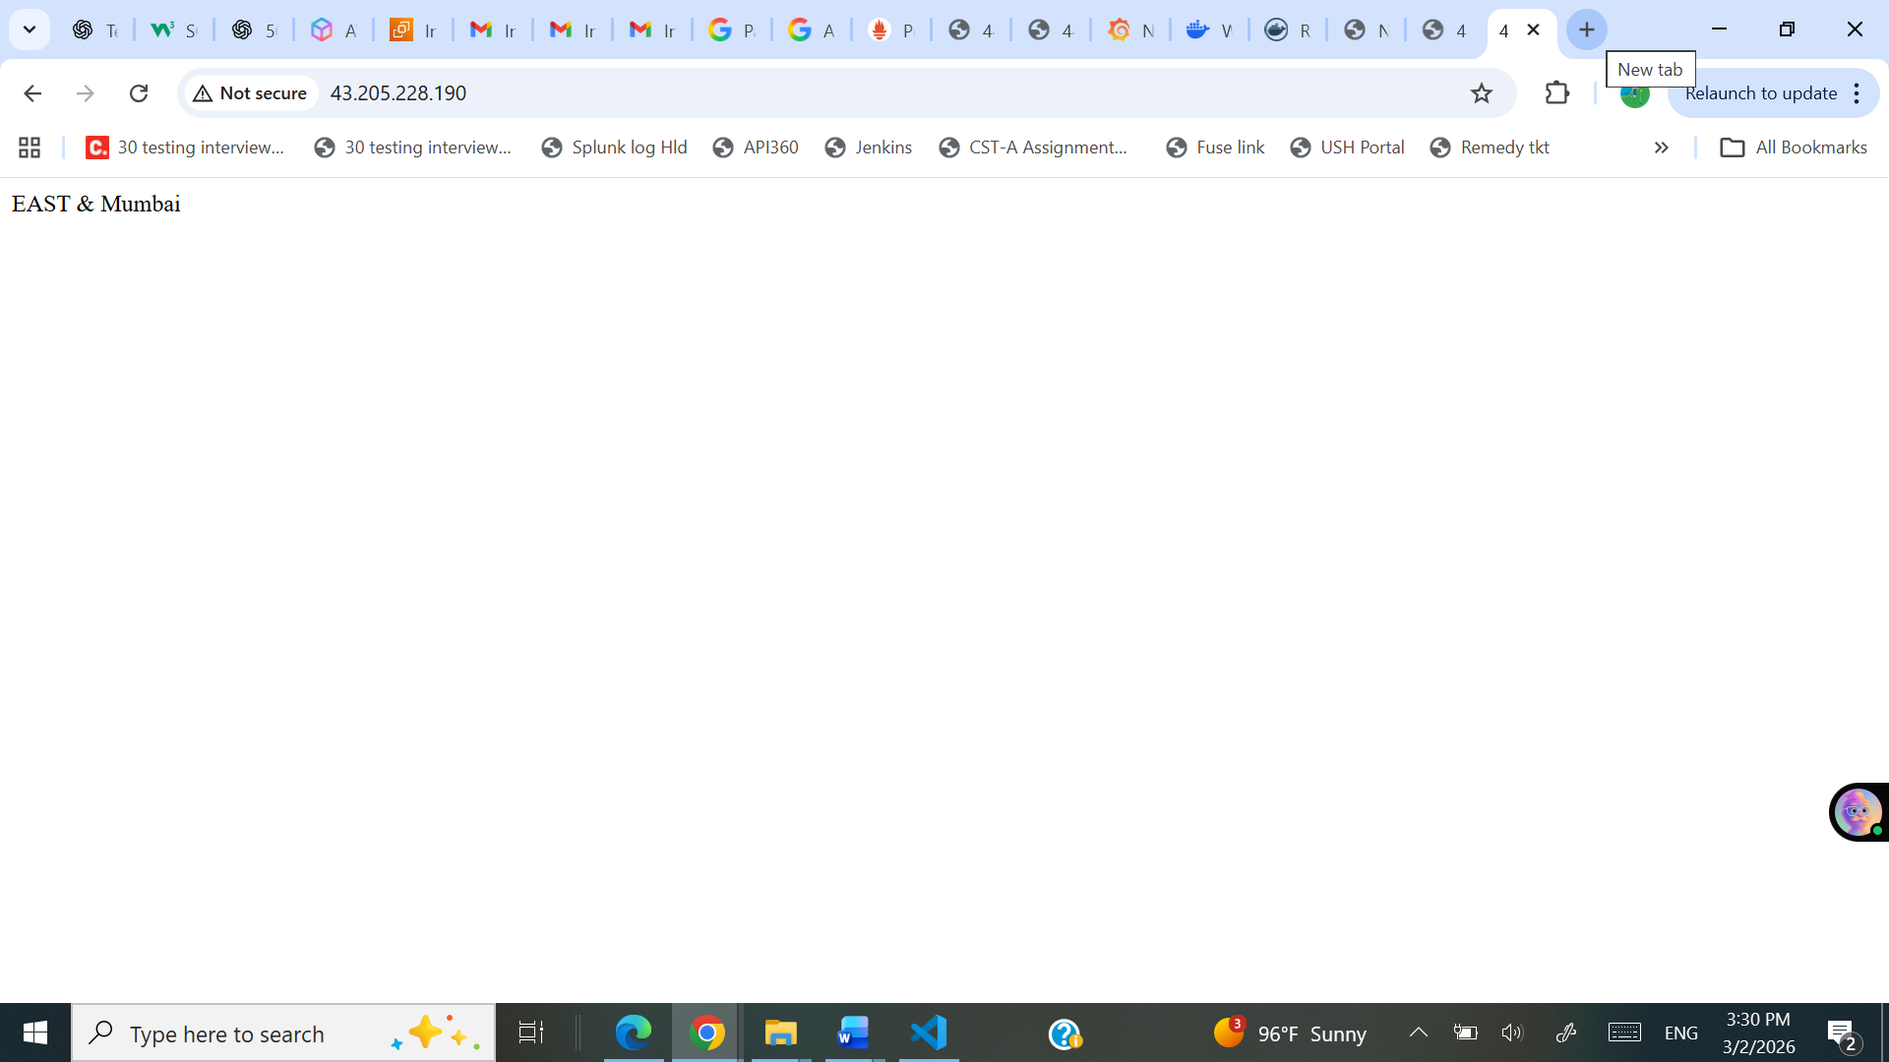
$ history
1 ls
2 vi main.tf
3 cat main.tf
4 clear
5 vi main.tf
6 cat main.tf
7 terraform -version
8 terraform init
9 1️⃣ Download Terraform
10 wget https://releases.hashicorp.com/terraform/1.6.6/terraform_1.6.6_linux_amd64.zip
11 unzip terraform_1.6.6_linux_amd64.zip
12 mkdir -p $HOME/bin
13 mv terraform $HOME/bin/
14 export PATH=$HOME/bin:$PATH
15 echo 'export PATH=$HOME/bin:$PATH' >> ~/.bashrc
16 source ~/.bashrc
17 terraform -version
18 terraform init
19 vi main.tf
20 rm main.tf
21 vi main.tf
22 terraform validate
23 cat main.tf
24 rm main.tf
25 vi main.tf
26 clear
27 terraform init
28 terraform plan
29 terraform apply
30 terraform destroy -auto-approve
31 clear
32 vi main.tf
33 terraform init
34 terraform plan
35 terraform apply
36 terraform destroy -auto-approve
37 vi main.tf
38 terraform init
39 terraform plan
40 terraform apply
41 history
42 terraform destroy -auto-approve
43 rm main.tf
44 vi main.tf
45 cleart
46 clear
47 vi main.tf
48 cat main.tf
49 terraform init
50 vi main.tf
51 terraform init
52 rm main.tf
53 vi main.tf
54 clear
55 terraform init
56 terraform fmt
57 terraform validate
58 clear
59 terraform init
60 vi main.tf
61 terraform init
62 vi main.tf
63 terraform init
64 vi main.tf
65 rm main.tf
66 clear
67 vi main.tf
68 terraform init
69 terraform fmt
70 terraform init
71 terraform fmt -check
72 terraform -version
73 terraform fmt
74 vi main.tf
75 rm main.tf
76 vi main.tf
77 terraform init
78 vi install_nginx.sh
79 cat install_nginx.sh
80 vi install_nginx.sh
81 vi main.tf
82 terraform fmt
83 terraform validate
84 terraform init
85 vi main.tf
86 cat main.tf
87 vi main.tf
88 terraform init
89 terraform plan
90 terraform apply
91 vi main.tf
92 terraform destroy -auto-approve
93 terraform apply -auto-approve
94 vi main.tf
95 terraform destroy -auto-approve
96 terraform apply -auto-approve
97 history
~ $

